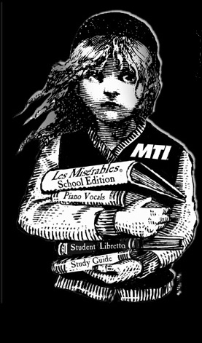
November 14, 2004.

Dear Parents and Guardians of the Les Mis Company;

We have all been working extremely hard these past few months, and the progress which we’ve seen is amazing and inspiring. To that end, we intend to invite the local media to publicize our efforts at the Sunday rehearsals. Photographs and articles are excellent, free advertising for the production. Because of this intention, we would ask that you sign the Consent for the Use and Routine Disclosure of Student Information form attached. This allows us to use photographs and personal information of our Company members for advertising and promotional purposes. This is part of the communication plan in an effort to share this newsworthy event with the community.

Photographs may be used in the following ways to promote the production:

- Photographs/student portraits, digital images, any pictures to be posted on the Internet, films, and video recordings collectively or individually, may be taken and may be used in the following manner:
- bulletin board displays in the classroom and in school hallways;
- school yearbooks/video/online yearbooks or school newsletters;
- in classroom activities, during open house, parents’ night, etc;
- may be shown to teachers for the purpose of planning activities;
- local newspapers and television stations.
- Board and school web pages

We also have a parent volunteer who has already started to share information about the production by creating a website. We want to post pictures of our cast, orchestra and crew during the remaining months in order to generate even more interest. This website is also an excellent avenue for communication with parents regarding changes to rehearsal schedules, costume drive, volunteering opportunities, etc. Check the updates at www.cottagelink.com/mis.

Thank you for your continued support and cooperation of this amazing adventure. If you have any concerns or questions, please feel free to contact Carole Aldworth or Beth Wolf at Resurrection, 741-1990; or call the Les Mis Attendance Line at 501-8034, and we will return your call as soon as possible. Thanks again!

Sincerely,

Carole Aldworth and Beth Wolf, Producers

